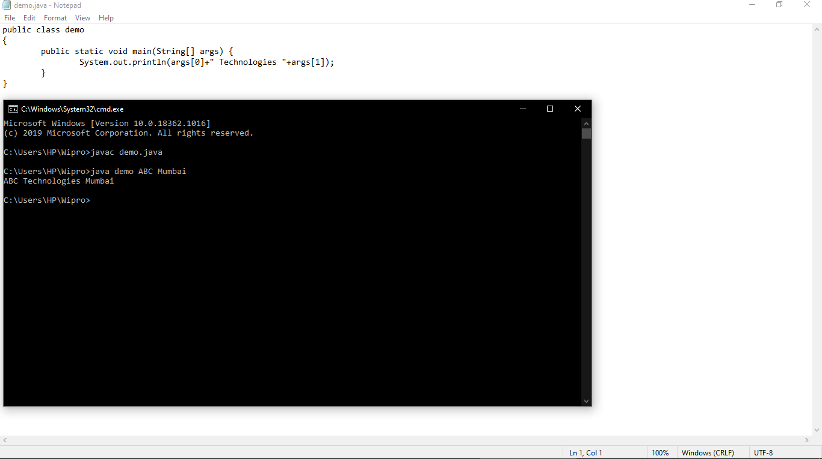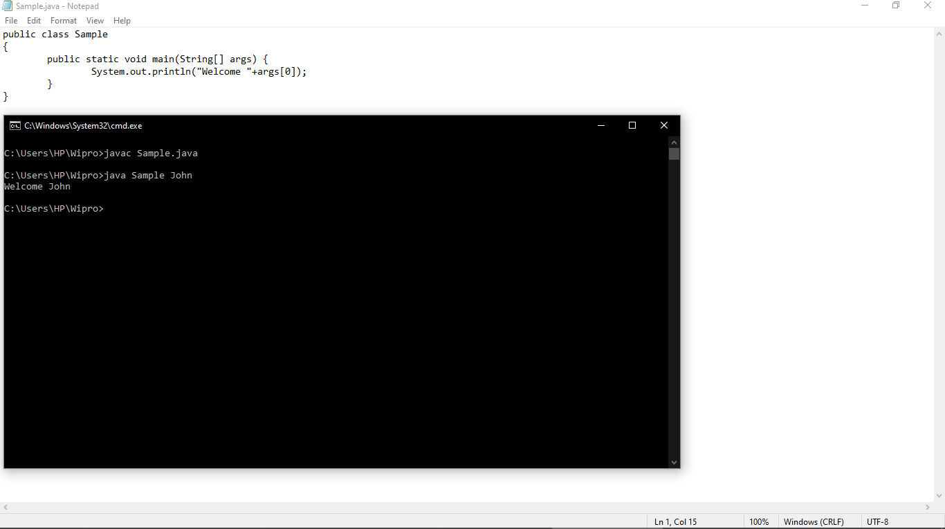Name : Dudekula Salman Registered number: Y17IT025

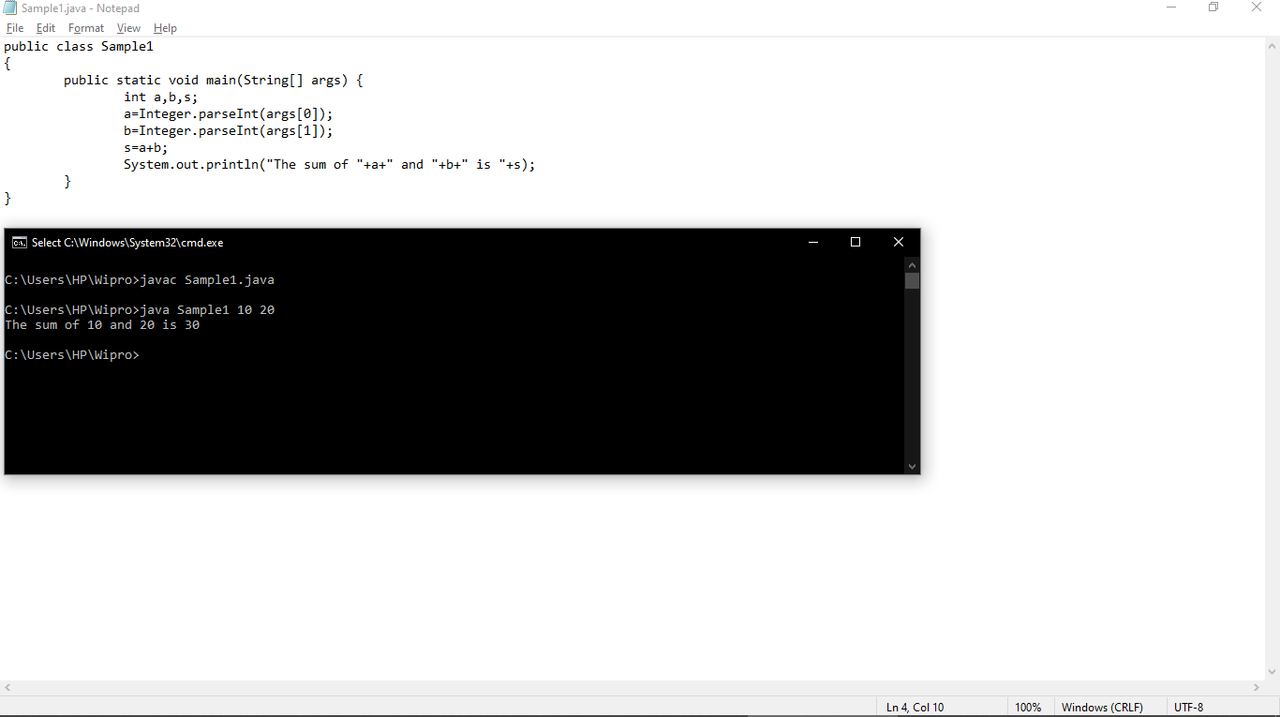

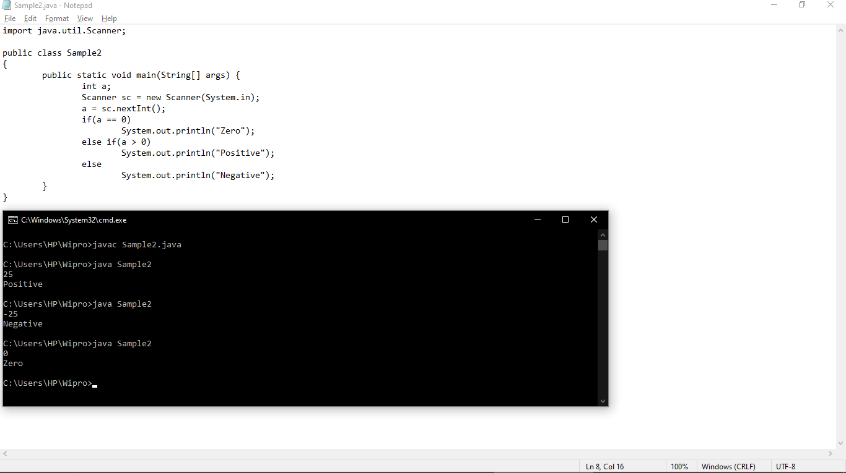

Thank you for using [www.freepdfconvert.com](http://www.freepdfconvert.com/) service!

Only two pages are converted. Please Sign Up to convert all pages. <https://www.freepdfconvert.com/membership>